Data Visualisation

First assignment

Tyler Slack

2024

Contents

Task 1: 2

Report: 3

Review: 9

# Task 1:

There are multiple policies and procedures that must be adhered to when handling data.

To begin, data privacy and confidentiality procedures must be followed to ensure all personal or sensitive data is protected under privacy laws. Within the UK, we follow GDPR (General Data Protection Regulation) which is described by the European Council as ‘the strongest privacy and security law in the world’ ([source](https://www.consilium.europa.eu/en/policies/data-protection/data-protection-regulation/#:~:text=The%20EU%20general%20data%20protection%20regulation%20(GDPR)%20is%20the%20strongest,the%201995%20data%20protection%20directive.)). These data protection laws aim to prevent the misuse of sensitive information and is important for a Data Analyst to know in order to maintain compliance.

Following on from this, it is important that data is also stored and accessed securely. The use of a password or encryption allows for enhanced security and prevents any misuse or unauthorised access. Understanding this as a data analyst will help prevent any data breaches and help to ensure responsible data handling.

Ethical data usage is also another policy that a data analyst must be conscious of while handling data. For example, within an economic/financial data set such as ‘The Wealth of Nations’ it is important to present findings in a transparent and objective way. Manipulating or changing data to influence decisions is corrupt and ethical integrity is an integral part of working with data.

Understanding and following these policies enables data analysts to work responsibly and ethically, safeguarding both data quality and stakeholder trust. Awareness of these policies not only prevents potential legal and ethical issues but also reinforces the value and reliability of the data-driven insights a data analyst provides.

# Report:

Excel

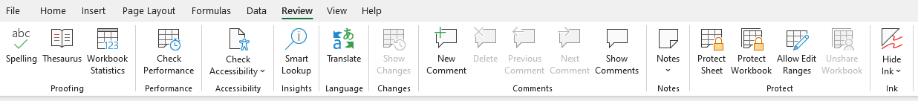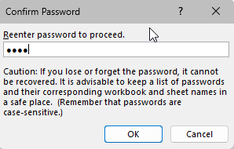



To follow GDPR policies, I began by creating a password protected encryption on the workbook. To do this, I clicked ‘Review’ on the ribbon, followed by ‘Protect Workbook’ followed with the password.

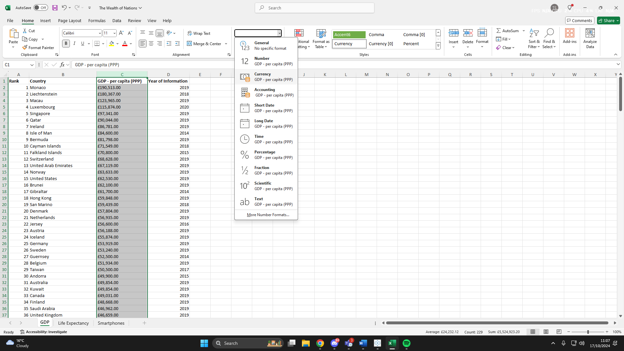

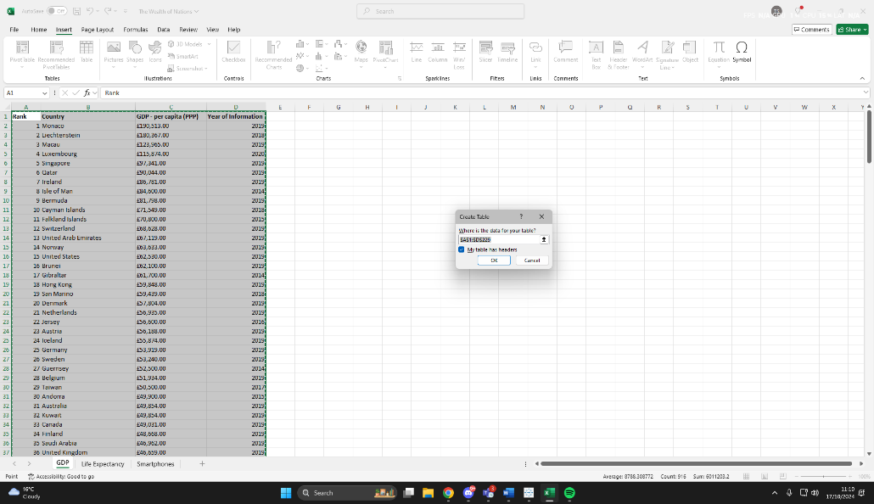After making GDP into £ currency, I turned the data into a table by highlighting the correct cells, clicking ‘Insert’ and then hitting ‘Table’.



I then edited the style of the table via the ‘Table Design’ section. I opted for a black and white style so the visualisations and macros would stand out more from the excel sheet.

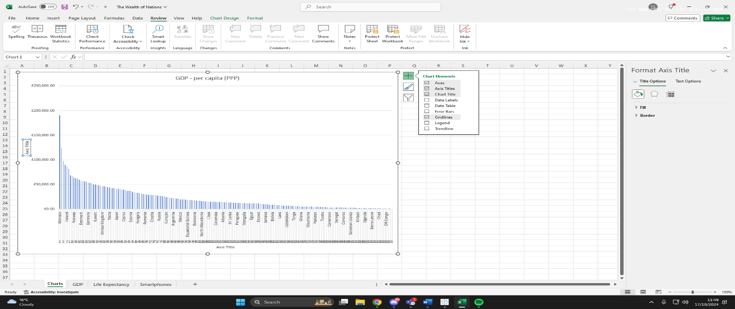Under the instructions, it states we should work with only data from 2019. So, I created a filter by clicking on the drop-down icon in the ‘Year of Information’ column and selected *only* 2019.



After, I created a chart that displayed only the columns Rank, Country and GDP and moved it to a new sheet and named it ‘Charts’.

I added a Title, X and Y axis labels and then made it more visually pleasing.

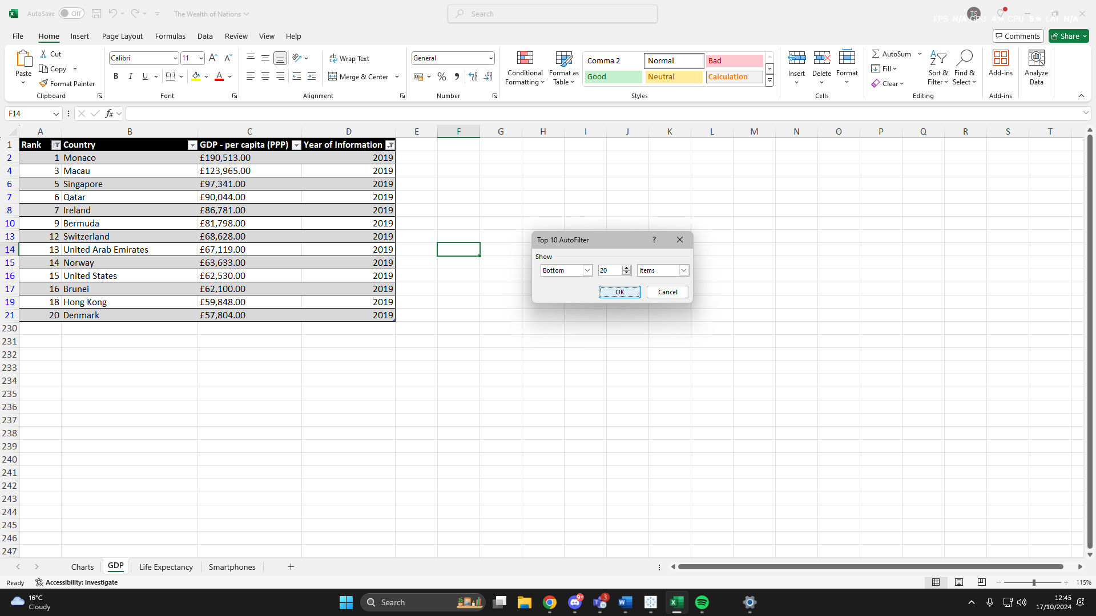In order to find the top 20 highest ranking countries, I created a sort using AutoFilter and filtered for the top 20 highest ranking countries and it came back with these entries.



A bar chart was then created to showcase this filtered table. In order to do this, I went ‘Insert’, and in the ‘Charts’ section, I selected a 2-D Bar Chart.

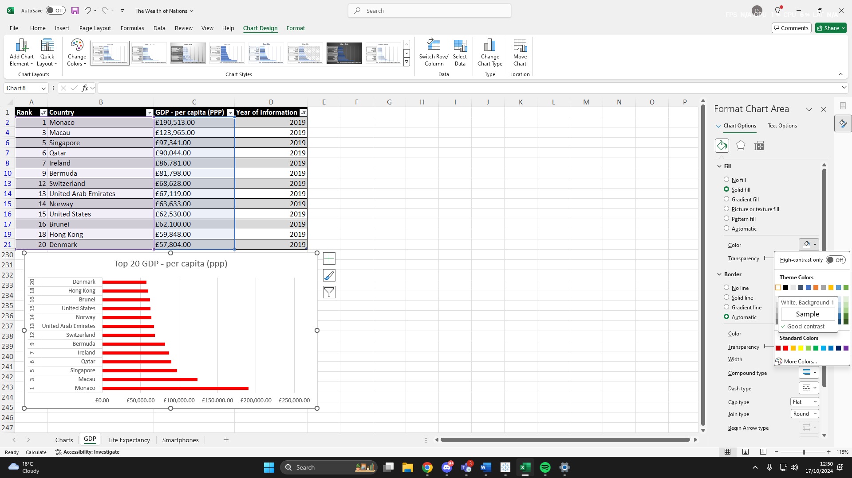



I also Formatted the chart to be more visually pleasing and changed the Fill option so it would stand out from the excel sheet grid.

Following the instructions, I then created a set of macro’s. In order to create the ‘Copy’ macro, I navigated to the ‘Views’ panel on the ribbon and then to ‘Macros’. I then hit ‘Record Macro’ and highlighted the area of cells I wanted to copy and then hit CTRL + C. I then navigated back to the ‘Macro’s’ section and hit ‘Stop Recording’. I then created a shape, formatted it to look more aestetically pleasing, right clicked and hit ‘Assign Macro’. Once there, I assigned the macro I had just created.

Tableau:

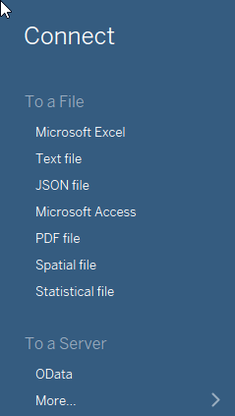



As ‘The Wealth of Nations’ data set is a .xlsx data type, I clicked Microsoft Excel and selected the file from the save location on my PC to import the data into Tableau.

After, I was met with this screen where I had to dictate the relationships between each sheet within the excel file.

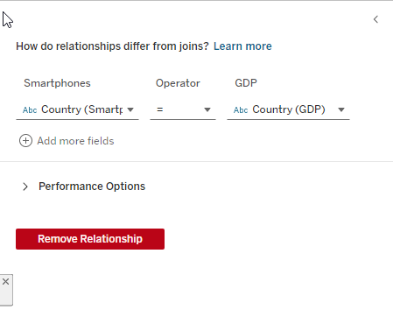The column ‘Country’ was present throughout each sheet so that was used as the relationship between each sheet.



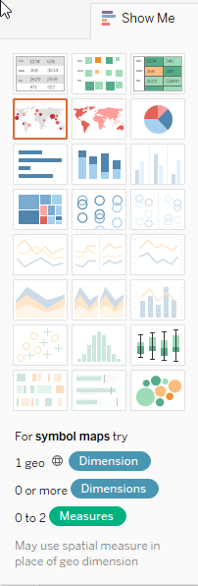

Now, as the client is colour-blind, when creating the visualisations I was conscious to not use colour as the primary representation of the data.



With this in mind, the first chart I created was a symbol map.

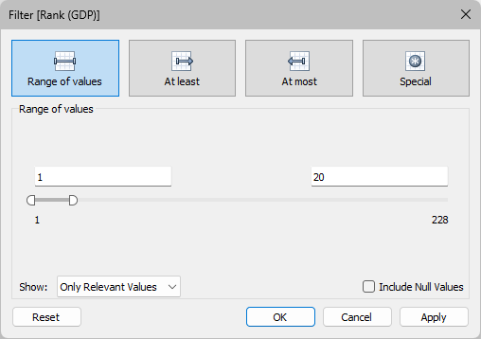I dragged Country into the Colour mark as each country name is already identified by the map. I then dragged Rank (GDP) into the Size mark for a visual representation of where each country sits in the ranking. I then dragged GDP per capita into the Labels mark to show each countries GDP above their circle as seen in the image on the right. As the client only wants to view the results of the top 20 countries, I then dragged Rank into the Filters section as arranged it as seen in the image below.

Next, I opted to create a bar chart. I dragged Country (GDP) into ‘Columns’ so it will be visualised as my X-axis. Then GDP – per capita was dragged into ‘Rows’ to provide the Y-Axis. Rank was also dragged into Filters again to only show the top 20. I also added Rank into the Label marker.

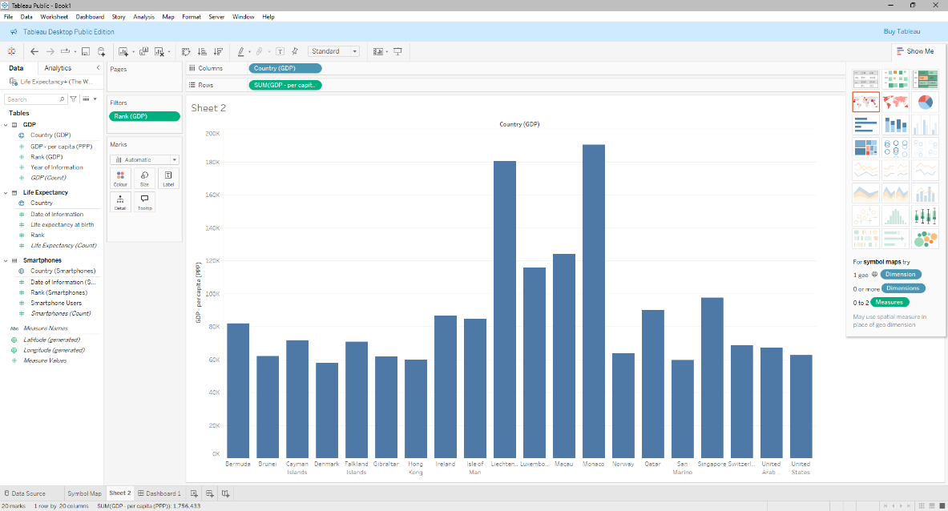



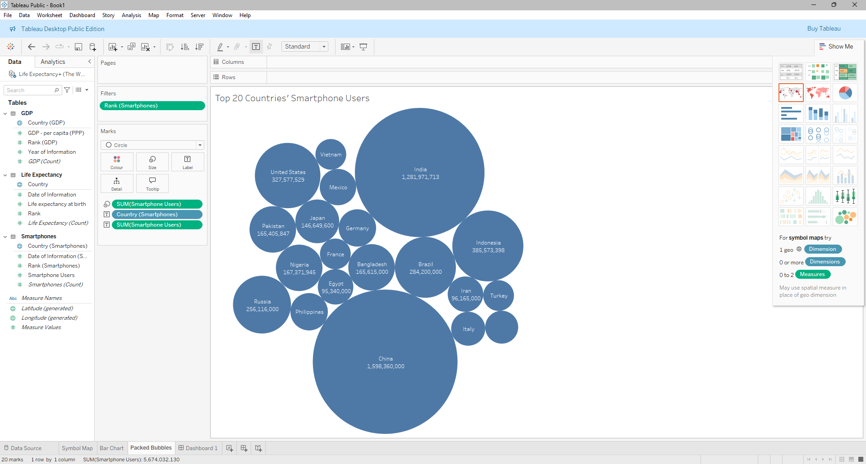

The next chart I decided on was the Packed Bubbles. I used Country AND Smartphone Users as my Label and Smartphone Users as my Size marker. I didn’t opt for a colour marker here again as the client is colour blind.

Again, I filtered the top 20 countries.

I then added a title to my chart by double clicking the text above the chart and renaming it as ‘Top 20 Countries’ Smartphone Users’ like the others.

Next, I created a horizontal chart showcasing the average life expectancy of the top 20 countries. To do this, I dragged Country into my Rows section and Life Expectancy into Columns, changing the data type to AVG. I then added a filter like the others and added a Label mark for Rank to show what each countries ranking is. I then click the Filter button next to the X-axis title and made the chart descend in ranking order.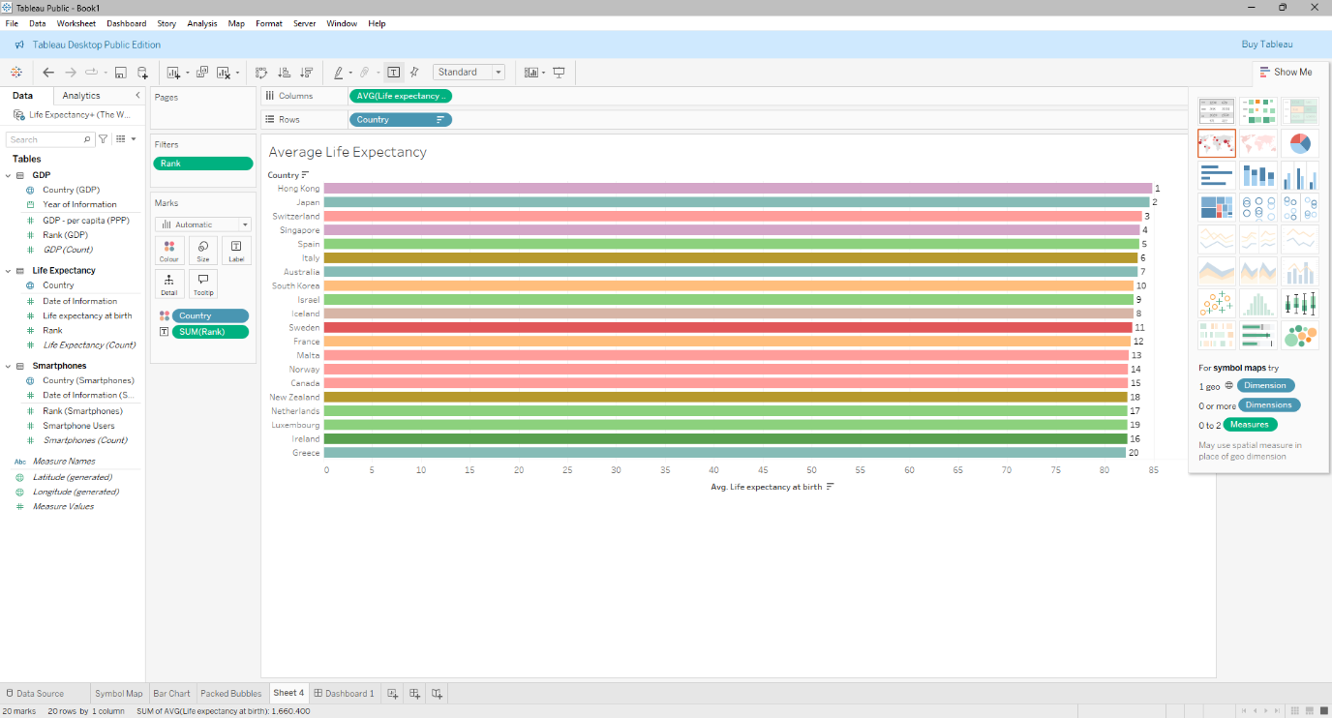

To now showcase all the visualisations, I created a dashboard. I clicked this icon at the bottom and a new dashboard opened.

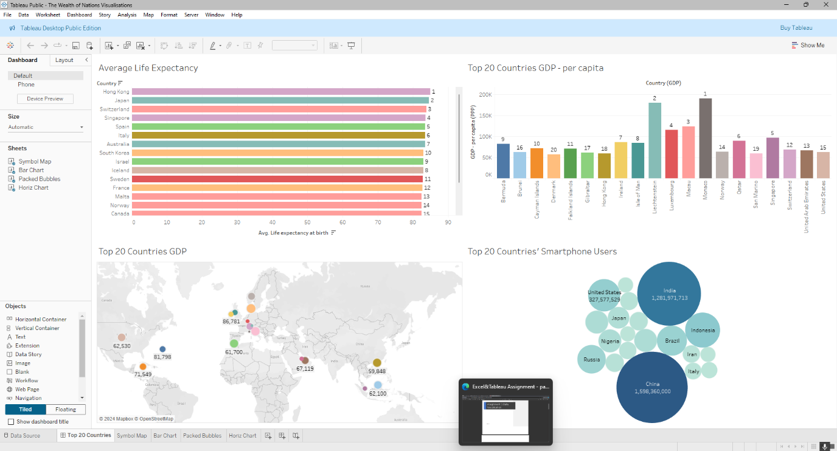Next, I had to drag and drop each sheet I worked on into the dashboard and arrange them, so all the data is visible.

# Review:

From working on this assignment, I have noticed I am a lot more confident working with Excel then I am with Tableau. Having used Excel in previous job roles and within my education I have a lot more experience with it and enjoyed that portion of the assignment more. Because of this, I now understand I need a lot more experience working within a Tableau environment and will dedicate time to become a lot more confident.